How to create a report of the number of reading lists citations created per year | 

Yoel Kortick
Senior Librarian

ONE
Create a report in the “Course Reserves” subject area

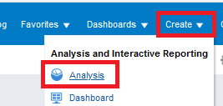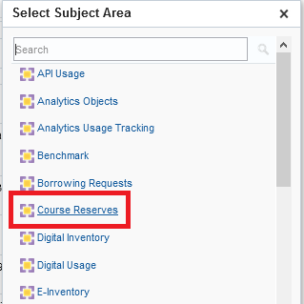

TWO
Display the following fields:

- "Reading List Citation Create Date > Citation Create Year")
- "Reading List Citation > Number Of Citations"

THREE

In the criteria tab filter by Course Create Date (Calendar) is not null (just filter by this field but do not display it)

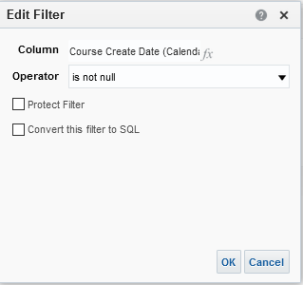

In the criteria tab filter by Citation Create Date Year is not null

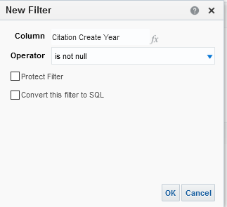

FOUR

Switch to “Results” tab and drag “Citation Create Year” to the left (if it is not there already):

